PUBLIC KEY CRYPTOGRAPHY, PKI & X.509 DIGITAL SIGNATURES

1. Public Key Cryptography (Asymmetric Crypto) — Overview
Public Key Cryptography uses a public/private key pair to secure communication, verify identity, and protect data integrity.
- Public Key → Shared freely
- Private Key → Secret, used for signing/decrypting
- Encryption & signature operations are mathematically linked but not reversible.
Example:
Sender encrypts using Receiver’s public key → Only Receiver's private key can decrypt.
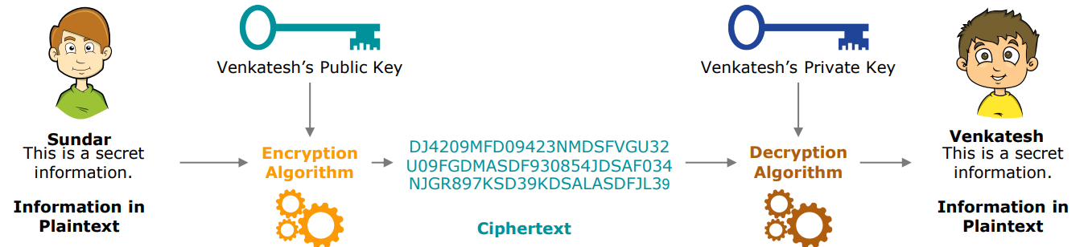

2. Digital Signatures — Core Concept
A digital signature is used to prove Integrity + Authentication + Non-repudiation.

How Digital Signing Works
- Message is hashed (SHA-256).
- Hash is encrypted using sender’s private key → signature.
- Signature is attached with the message.

Verification
- Receiver hashes message again.
- Signature decrypted using sender’s public key.
- If both hashes match → signature valid.
Use Cases:
- Secure emails
- Software signing
- Legal documents
- SSL/TLS authentication

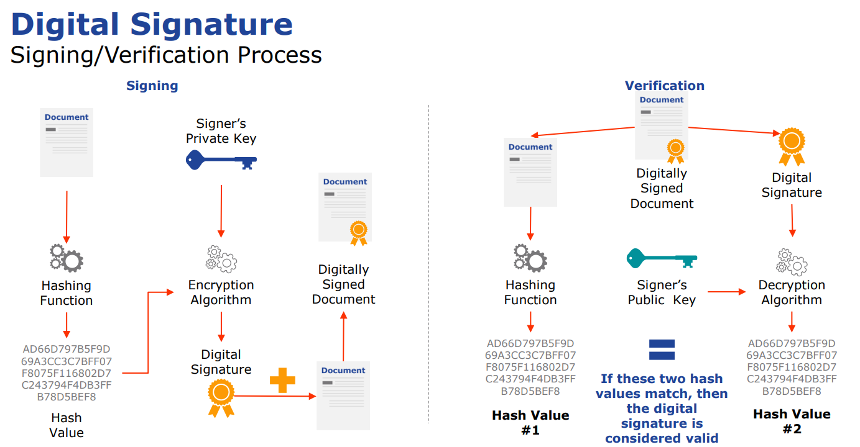

3. X.509 Certificates — Summary
X.509 certificate binds a public key with an identity (person, server, organization).
Issued & digitally signed by a Certificate Authority.

Fields inside an X.509 Certificate
- Version, Serial Number
- Subject (owner)
- Public Key
- Issuer (CA name)
- Validity (start/end)
- Signature Algorithm & Signature
- Key Usage (encryption, signing, etc.)

Why X.509 is important?
- Prevents fake identities
- Ensures trusted communication
- Used in SSL/TLS, VPN, Email, IoT devices
Ya to pic wala likhna ha ya upper wala 3rd
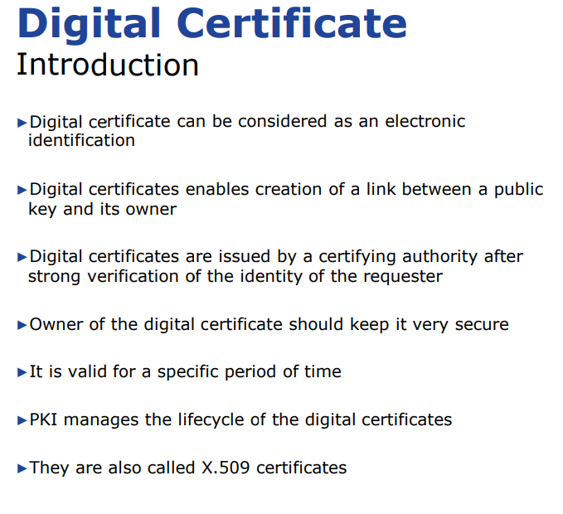

4. PKI (Public Key Infrastructure) — Brief Summary
PKI is the entire security ecosystem enabling trust on the internet.

PKI Provides
- Key generation and storage
- Certificate issuance & renewal
- Authentication of identities
- Digital signatures
- Secure distribution of public keys
- Revocation of compromised certificates

Core PKI Roles
- CA (Certificate Authority) – issues certificates
- RA (Registration Authority) – verifies identity
- Repositories – store certificates
- CRL/OCSP – validate revocation
- Policy authority – defines rules

